U. P. Athletics Association
Affiliated to U. P. Olympic Association & Athletics Federation of India

Annual General Council Meeting (AGCM)
30th APRIL 2023 (Sunday)
The SPORTZ HUB, Arya Nagar, KANPUR

ELECTION/NOMINATION of EXECUTIVE COMMITTEE

PROCEDURE of ELECTION

Before 15th April 2023 (Saturday):

- Notice of Annual General Council Meeting (AGCM)
- Notice to all Affiliated Members of District Athletics Associations & Units (One representative) for sending names of their representative.
- The Returning Officer will be nominated for conduct of Election of Executive Committee in accordance with the Constitution of U. P. Athletics Association (UPAA)

Day “1” * 15th APRIL 2023: Each Affiliated Member shall intimate the name of its representative.

Day “2” * 16th APRIL 2023: The Secretary UPAA shall prepare the list of the authorised representative of Each Affiliated Member and furnish duly authenticated list to the Returning Officer and display it on the Web-site of UPAA. (Form ‘1’)

Day ‘3’ to ‘6’ * 17th to 20th April 2023: Each Nomination shall be prepared in accordance with the UPAA Constitution. Each nomination paper shall be delivered personally to the Returning Officer or his authorized representative in person by the candidate himself/herself from 17th April 2023 to 20th April 2023 (Form ‘2’)

Day ‘7’ * 21st April 2023: The Returning Officer shall prepare a list of nominations received by him post wise and publish the same in a conspicuous place in his office. (Form ‘3’)

Day ‘8’ * 22nd April 2023: Scrutiny: The Returning Officer in his office shall scrutinize each nomination paper, one by one, received by him and determine its validity or otherwise. After the scrutiny of all nomination papers, the Returning Officer shall prepare a list of validly nominated candidates and contesting candidates can collect a copy from the Returning Officer. (Form ‘4’)

Day ‘8’ to ‘10’ * 22nd to 24th April 2023: Withdrawal: Each candidate whose nomination has been found valid after scrutiny shall be entitled to withdraw his/her candidature latest by 24th April 2023. The Returning Officer shall accept the notice of withdrawal if he is satisfied as to the genuineness of the notice. (Form ‘5’)

Day ‘11’ * 25th April 2023: After the expiry of the time, the Returning Officer shall prepare a Final List of contesting Candidates and display a copy of the list in a conspicuous place in his office and on UPAA’s Website. And also furnish a copy of the same to each of the candidate / their authorized representatives, if they so demand. (Form ‘6’)

Uncontested Returns and Contested Elections:

- Where the number of contesting candidates for any post is equal to the number of post(s) to be filled, all such contesting candidates shall be deemed to be duly elected unopposed to those posts.
- Where the number of contesting candidates for any post is more than the number of posts to be filled, a poll shall be taken by secret ballot for those post(s) remaining unfilled.

Contd.
U. P. Athletics Association
Affiliated to U. P. Olympic Association & Athletics Federation of India

Annual General Council Meeting (AGCM)
30th APRIL 2023 (Sunday)
The SPORTZ HUB, Arya Nagar, KANPUR

ELECTION/NOMINATION of EXECUTIVE COMMITTEE

PROCEDURE of ELECTION
Contd.

Day ‘16’ – 30th April 2023 (Sunday):

Polling: The Poll for the Post(s) remaining unfilled shall be taken post-wise on day ‘16’ and shall commence at during the AGM at the agenda item no. ‘9’ i.e. Election of Executive Committee at Kanpur (Venue: The Sportz Hub, Palika Stadium, Arya Nagar, Kanpur)

The tick mark ( √ ) against the name of the candidate(s) of his/her choice by means of article specifically provided for the purpose by the Returning Officer.

The ballot paper marked by a voter shall be deposited by him/her in ballot box specifically prepared and sealed by the Returning Officer and placed in a conspicuous place in the polling station that it shall be constantly visible to all present in the polling station.

The Returning Officer shall close the poll at the appointed hour.

Counting of Votes: The Returning Officer shall take up the counting of the votes as soon as may be after the polling of all posts is complete.

The Returning Officer shall thereafter ascertain the result of counting and the candidates who have secured maximum number of votes in the said descending order, post wise, where applicable, equal to the number of seats to be filled for each post(s), shall be deemed to have been duly elected to those posts.

Declaration of the Result: The names of contesting candidates, who shall be deemed to have been elected in the election, shall be declared as having been duly elected to their respective posts, by the Returning Officer at the Annual General Council Meeting (AGCM).

P.K.Srivastava
Secretary
U.P. Athletics association
8th April 2023.

U. P. Athletics Association
Affiliated to U. P. Olympic Association & Athletics Federation of India

Annual General Council Meeting (AGCM)
30th APRIL 2023 (Sunday)
The SPORTZ HUB, Arya Nagar, KANPUR

ELECTION/NOMINATION of EXECUTIVE COMMITTEE

PROCEDURE of ELECTION

Before 15th April 2023:

- Notice of Annual General Council Meeting (AGCM) {08.04.2023}
- The President/Secretary shall nominate Returning Officer.

Day “1” * 15th April 2023 (Saturday): Name of the representative of all Affiliated District Associations and Units.

Day “2” * 16th April 2023 (Sunday): Preparation of the list of the authorised representatives of Affiliated District Associations and Units and furnish duly authenticated list to the Returning Officer and display on the Web-site of UPAA.
(Form ‘1’)

Day ‘3’ to ‘6’ * 17th to 20th April 2023 (Monday to Thursday): Nominations for the post of Executive Committee is to be delivered personally to the Returning Officer or his authorized representative.
(Form ‘2’)

Day ‘7’ * 21st April 2023 (Friday): Preparation of list of nominations and publish the same in UPAA Website.
(Form ‘3’)

Day ‘8’ * 22nd April 2023 (Saturday): Scrutiny: After scrutiny of nominations, preparation of a list of validly nominated candidates.
(Form ‘4’)

Day ‘8’ to ‘10’ * 22nd to 24th April 2023 (Saturday to Monday): Withdrawal: Withdrawl of candidature.
(Form ‘5’)

Day ‘11’ * 25th April 2023 (Tuesday): Preparation of Final List of contesting Candidates and display it on Association’s Website.
(Form ‘6’)

Uncontested Returns and Contested Elections:

- If number of contesting candidates for any post is equal to the number of post(s) to be filled, all such contesting candidates shall be deemed to be duly elected unopposed to those posts.
- If the number of contesting candidates for any post is more than the number of posts to be filled, a poll shall be taken by secret ballot for those post(s) remaining unfilled.

Day ‘16’ – 30th April 2023 (Sunday): Polling: The Poll for the Post(s) remaining unfilled shall commence during the AGCM i.e. Election of Executive Committee at Venue of the AGCM.

Counting of Votes: Counting of the votes after the polling of all posts is complete.

Declaration of the Result: The names of “Elected Executive Committee Members” post wise (either unopposed or elected through the Election procedure), shall be declared as having been duly elected to their respective posts, by the Returning Officer at the Annual General Council Meeting (AGCM).

P.K.Srivastava
Secretary Place: Kanpur
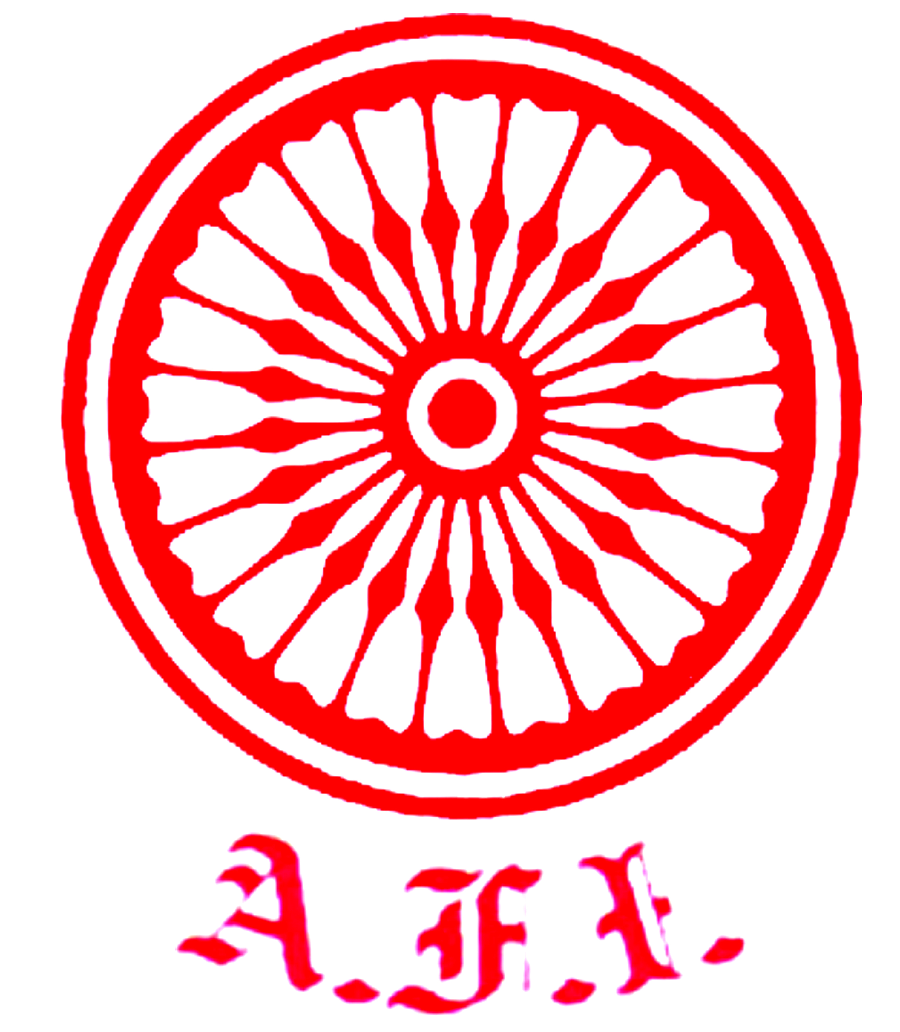
ATHLETICS FEDERATION OF INDIA

EXTRACT of CONSTITUTION AFI
Appendix
ELECTION PROCEDURE

- Each member unit duly affiliated with the Federation (AFI) will intimate the name (s) of their representatives within four days from the notification of the date of elections. (According to the rule XV - VOTING)
- The notice of the Annual General Assembly Meeting (AGM) will be sent to all Members Unit(s) fifteen (15) clear days in advance.
- The President/Secretary AFI will nominate the Returning Officer.
- The President / Secretary will prepare the list of authorized representatives of the Member Unit(s) who are authorised to vote and circulate this list to all member Unit(s), 11 (Eleven) days before the AGM. This list of Electoral College will be handed over to the Returning Officer on the same day. {i.e. the day when it is circulated to all Member Unit(s)}.
- Nomination for any post of Elected Member shall be proposed by one of the authorized representative of the Member Unit(s) whose name is included in the Electoral College list, and also subscribed by one such representative as seconder.
- No person shall be eligible to nominate more than one candidate for the same post, either as proposer or seconder; and if he so does, his/her signature on the nomination papers delivered second in point of time to the Returning officer shall be deemed to be inoperative.
- No person shall be permitted to withdraw his/her name as proposer/seconder, once the nomination paper subscribed by him/her has been delivered to Returning Officer.
- Nomination for the various post of the Elected members will be filed within 4 (Four) days from the circulation of the Electoral College.
- Returning Officer will scrutinize and prepare the list of valid nominations, Post wise and publish it on the last day of filling the nominations.
- The withdrawal of nomination may be made within 2 (Two) days from publishing of list of valid nomination by the Returning Officer.
- The Returning Officer will prepare the Final list of contesting candidates and display it on the Federation (AFI) web-site on the last date fixed for withdrawal of nomination.
- Where the number of contesting candidates for any post is equal to the number of posts to be filled, all such contesting candidates shall be deemed to be duly elected unopposed to those posts and it shall not be necessary to take a poll for election to such post.
- Where the number of contesting candidates for any post is more than the number of posts to be filled, a poll shall be taken by secret ballot for those post(s) only.
- At the poll, each authorized representative, whose name is included in the Electoral College list shall be entitled to:
i) cast one vote for each of the posts remaining unfilled, where only one such seat is to be filled.
ii) cast as many votes as are the number of seats to be filled for any post, where more than one seat is to be filled.
- The Annual General Assembly (AGM) will be held and if required and polling for the post of the Elected members will be held in the AGM only. The counting of Votes will be done immediately after the voting is complete.
- Returning Officer will declare the Result of all the Posts of Elected members after the whole process of Election is over.

Note: 1. In any case, No proxy voting will be allowed.
2. All employees of State & Central Government, who desire to contest the elections will require prior written permission as per the rules of the respective government through their competent authority.

~*~*~*~
U. P. Athletics Association
Affiliated to U. P. Olympic Association & Athletics Federation of India

Annual General Council Meeting (AGCM)
30th APRIL 2023 (Sunday)
The SPORTZ HUB, Arya Nagar, KANPUR

ELECTION/NOMINATION of EXECUTIVE COMMITTEE

PROCEDURE of ELECTION

FORMS

Form ‘1’: Llist of the authorised representatives of Affiliated District Associations and Units

Form ‘2’: Nominations for the post of Executive Committee

Form ‘3’: List of nominations published in UPAA Website.

Form ‘4’: Validly nominated candidates.

Form ‘5’: Withdrawal of candidature.

Form ‘6’: Final List of contesting Candidates and display on UPAA’s Website.

Form ‘7’ TO ‘14’: Ballot Papers for President, Secretary, Treasurer, Sr. Vice President, Vice Presidents, Sr. Joint Secretary, Joint Secretaries, Executive Committee Members.

Form ‘15’: Declaration of Results.

