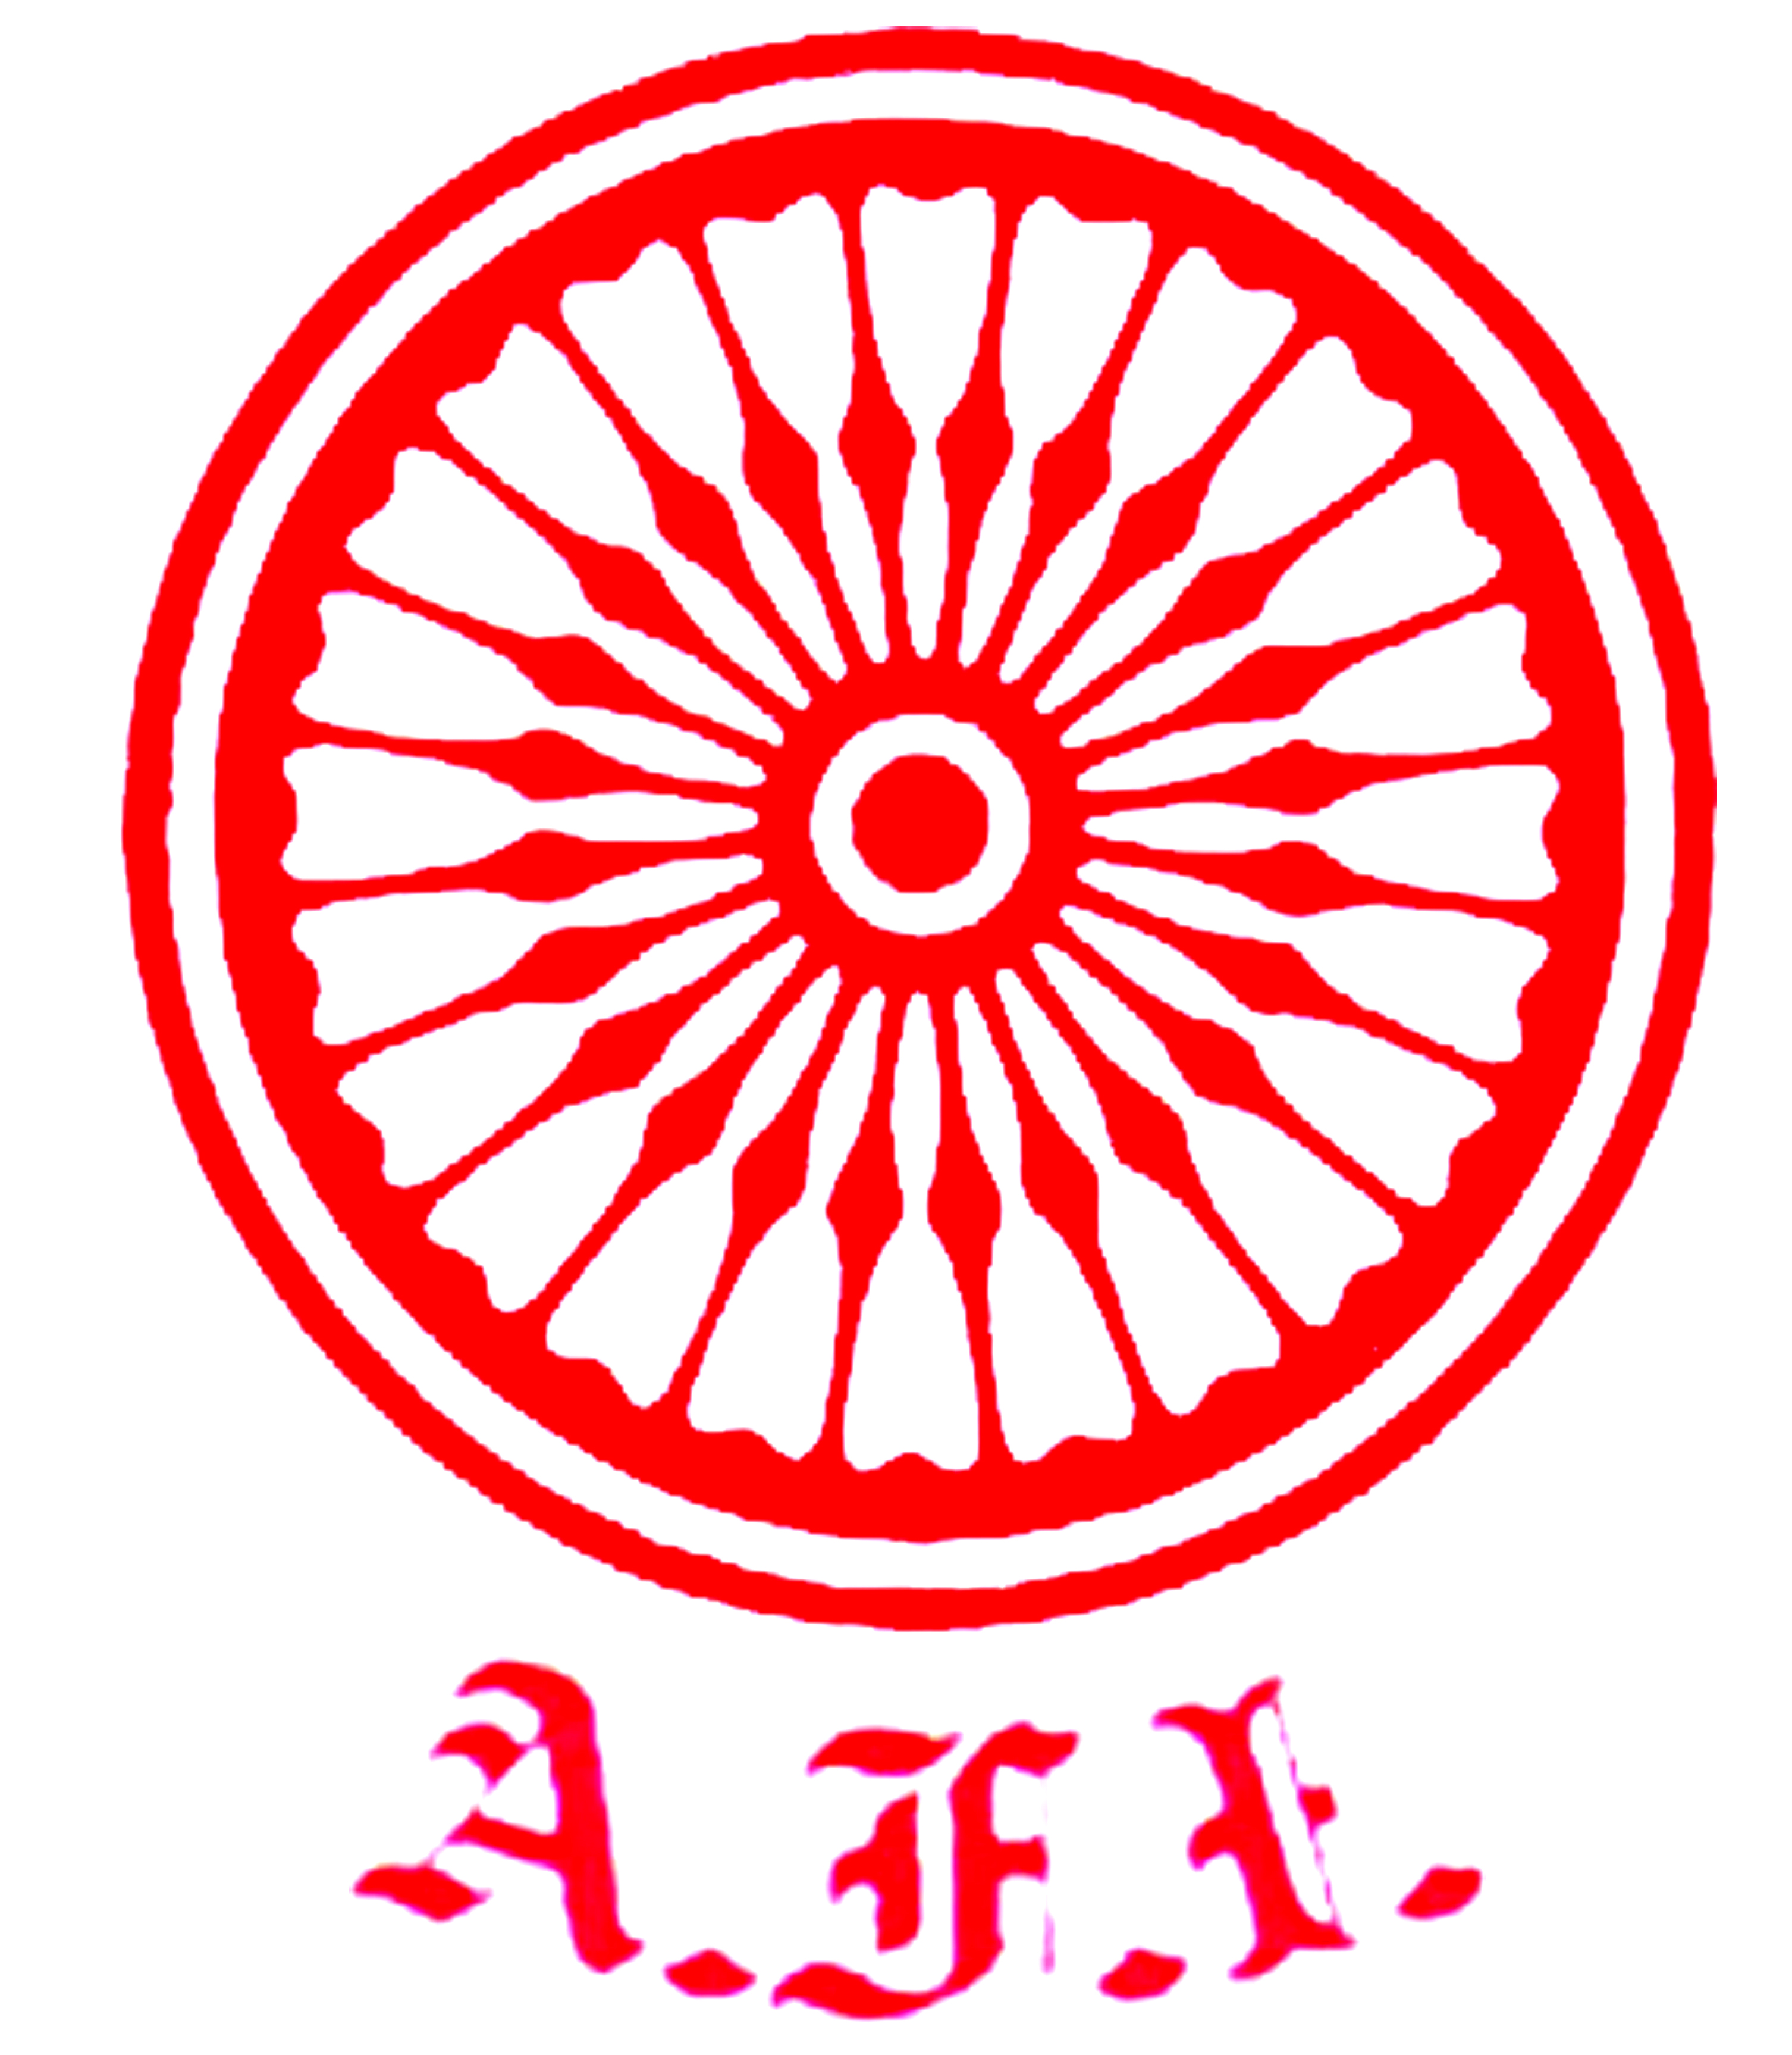
U. P. Athletics Association

Initiative of ATHLETICS UTTAR PRADESH
Under the auspices of Athletics Federation of India
“दिशा”
7th to 10th June 2020 * Sunday to Wednesday * 11.00 am

Educational Deliberations for the Coaching Fraternity of Uttar Pradesh

9th June 2020 * Tuesday * Day “3”

~: Chairman of the Session :~
Sri Ravinder Chaudhry – Vice President AFI

10.45 – 10.55 hrs. Assembly of Participants from all over Uttar Pradesh.

10.55 hrs. Arrival of Dignitaries & Hony President / Chairman of U.P. Athletics Association.
Arrival of Executives & members of U.P. Athletics Association
.
11.00 hrs. Skill Teaching & Coaching Skills by Mr. P. Radhakrishnan Nair

- Dy. Chief National Coach – Indian Athletics - AFI.
- Coaching Development Director – AFI.
- World Athletics Coaches Education level ‘1’ & level ‘2’ Lecturer.
- World Athletics Level ‘5’ Coach.
- Graduated with Honour in International Coaches Enrichment Certificate Programme,
Delaware University, USA – under the sponsorship of IOC

12.00 hrs. Youth Development by Mrs. Anjani Dubey
Long Term Athlete Development

- Former International Athlete.
- Athletics Coach in IIT Kanpur.
- AFI - Level ‘1’ Technical Official.

13.00 hrs. Vote of Thanks by Mr. Dinesh Kumar Jaiswal
Chairman – Coaching Committee UPAA
~: Eminent faculty :~

Mr. P. Radhakrishnan Nair (Dy.Chief National Coach AFI) Mrs. Aradhana Sharma (Nutritionist, Pune)
Mrs. Anjani Dubey (Ex-International Athlete, IIT Kanpur) Mr. G. Rajaraman (Senior Journalist)
Dr. Jai Prakash Bhukar (Central University of Haryana) Mr. Parvir Singh (Athletics NS NIS Patiala)
Mr. Kamal Ali Khan (Chief National Coach ‘Juniors’ - AFI) Ms. Ishita Dass (Athletics NS NIS Patiala)
Mr. Siddhartha Krishna (Athletics Uttar Pradesh- Saifai) Mrs. Rachita Mistry (International Athlete)
Mr. Sandeep Sarkaria ( Elite International Athlete) Mr. Parth Goswami (Legal Advisor, AFI)

*~*~*~*

Mr. Anil Kumar Sagar, IAS Dr. Devesh Dubey P. K. Srivastava
Sr. Vice President Treasurer Hony Secretary
Chairman Planning Committee HOST Organiser

~: COORDINATORS :~

Sri Dinesh Kumar Jaiswal Chairman Coaching Committee  Mobile – 9415372693  Email - dineshsandhya1958@gmail.com | Sri Siddhartha Krishna - Executive Committee member  Mobile – 7376922226  Email – siddhuwalk46@gmail.com

