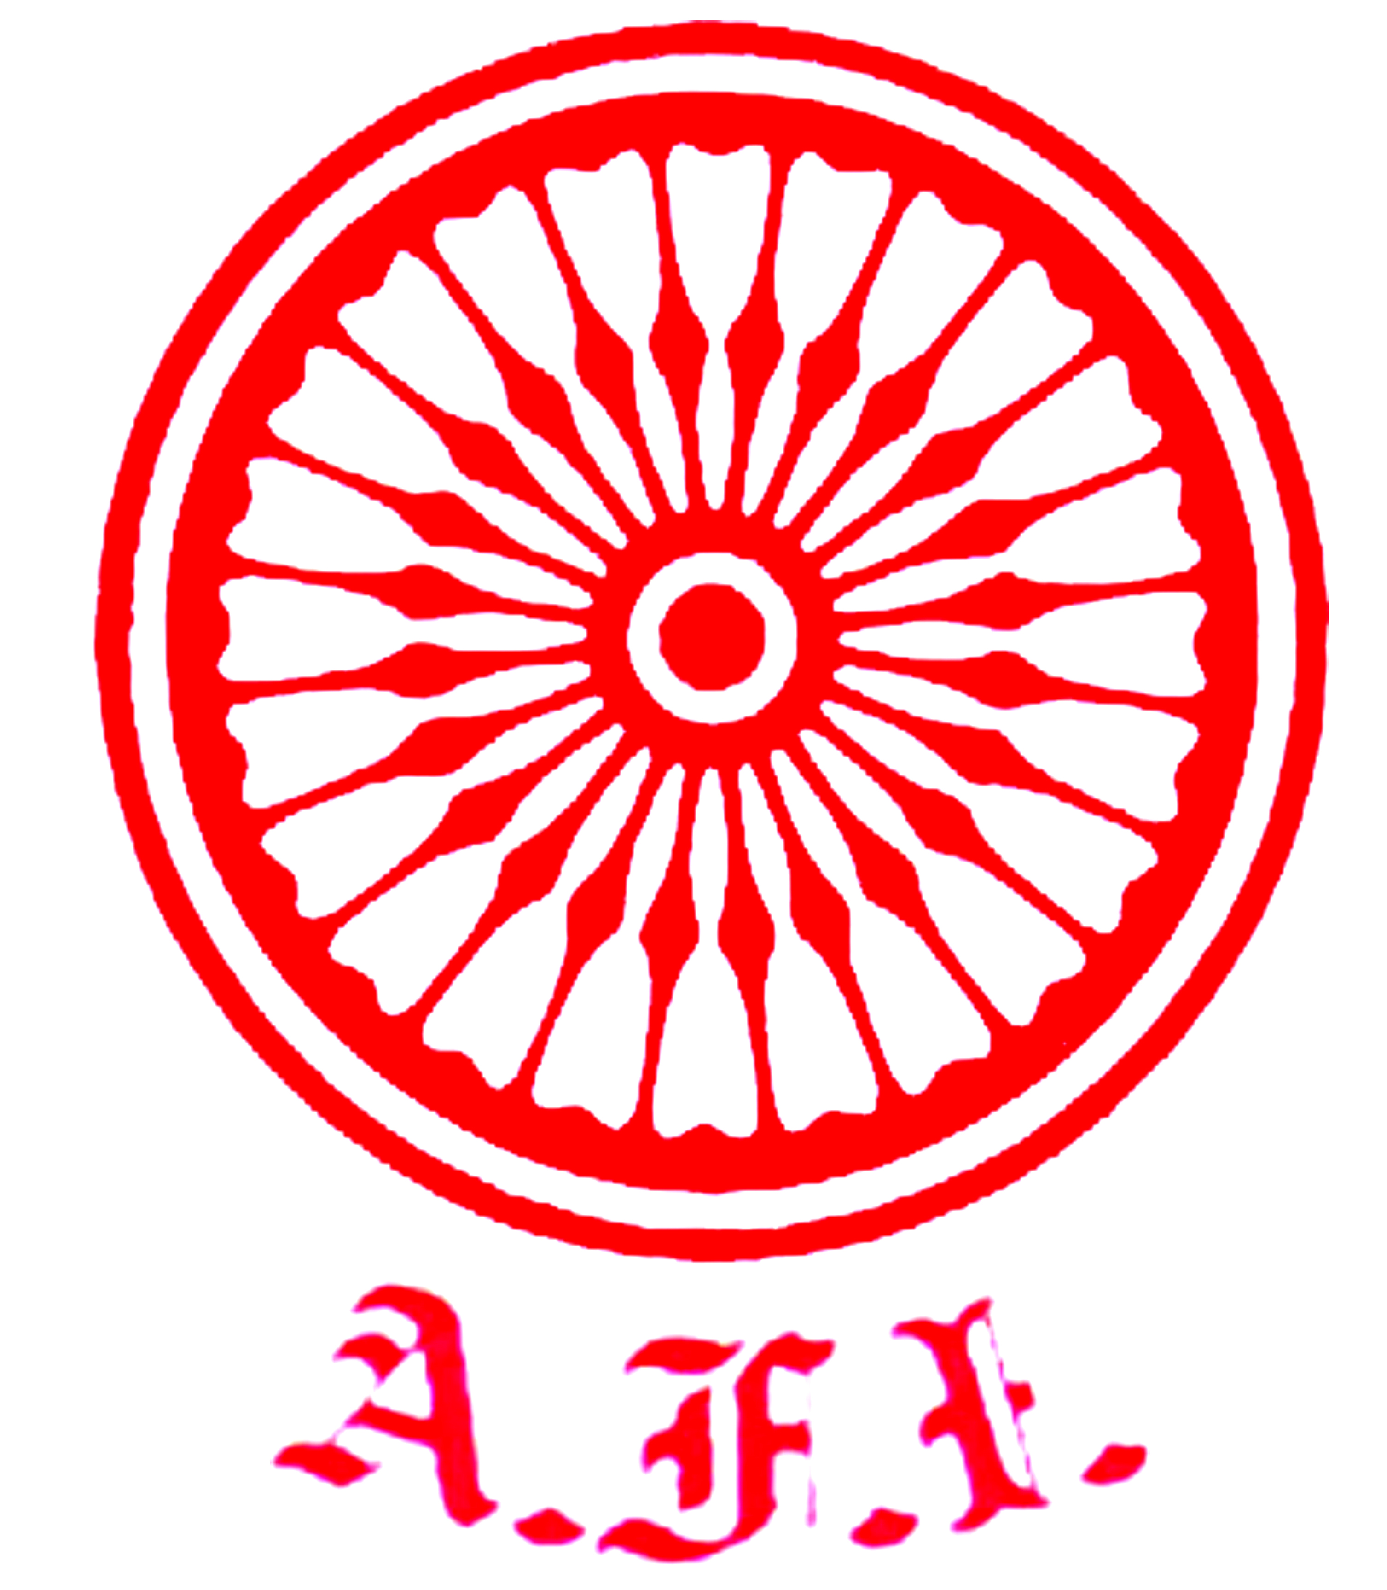
U. P. Athletics Association

Initiative of ATHLETICS UTTAR PRADESH
Under the auspices of Athletics Federation of India
“दिशा”
7th to 10th June 2020 * Sunday to Wednesday * 11.00 am
Educational Deliberations for the Coaching Fraternity of Uttar Pradesh

Closing Ceremony

10th June 2020 * Wednesday * Day “4”

Chief Guest
Sri Kunwar Fateh Bahadur, IAS (Retd.)
Senior Vice President – AFI & Hony President UPAA
Guest of Honour Chairman of the Session
Sri C. K. Valson Sri M. K. Pathak
Hony Secretary – AFI Joint Secretary – AFI
Eminent Faculty – Guest of Honour

Sri Kamal Ali Khan Sri G. Rajaraman Sri Sandeep Sarkaria Smt. Rachita Mistry
Chief National Coach Senior Journalist Former International Athlete Former International Athlete

10.15 – 10.25 hrs. Assembly of Participants from all over Uttar Pradesh.

10.25 hrs. Arrival of Hony President U.P.Athletics Association.
Welcome Address by Chairman UPAA Sri Ashutosh Bhalla Ji.
Speech by Chief Guest Sri Kunwar Fateh Bahadur Ji - Sr. Vice President AFI.
Speech by Hony Secretary AFI - Sri C. K. Valson.
Introduction by Chairman of the Session - Sri M.K. Pathak – Joint Secretary AFI.
10.35 hrs. Thanks Address by Dr. Devesh Dubey - Treasurer UPAA
10.40 hrs. Athletics Planning – A Perspective by Sri Kamal Ali Khan
- Chief National Athletics Coach - Juniors.
- Former International Athlete
- World Athletics level ‘1’ Coach.
11.30 hrs. An Athletes’ Perspective
Sri G. Rajaraman
- Senior Journalist,
- Student of Sports,
- Guide & Friend of Athletics Uttar Pradesh.
Sri Sandeep Sarkaria & Smt. Rachita Mistry
Former International Athlete Former International Athlete

12.15 hrs. Question & Answers Session
12.30 hrs. Vote of Thanks Address by Sri Ajay Kumar Tripathi - Joint Secretary UPAA.

*~*~*~*
Mr. Anil Kumar Sagar, IAS Dr. Devesh Dubey P. K. Srivastava
Sr. Vice President Treasurer Hony Secretary
Chairman Planning Committee HOST Organiser

~: COORDINATORS :~
Sri Dinesh Kumar Jaiswal Chairman Coaching Committee  Mobile – 9415372693 * Email - dineshsandhya1958@gmail.com | Sri Siddhartha Krishna - Executive Committee member  Mobile – 7376922226 * Email – siddhuwalk46@gmail.com

