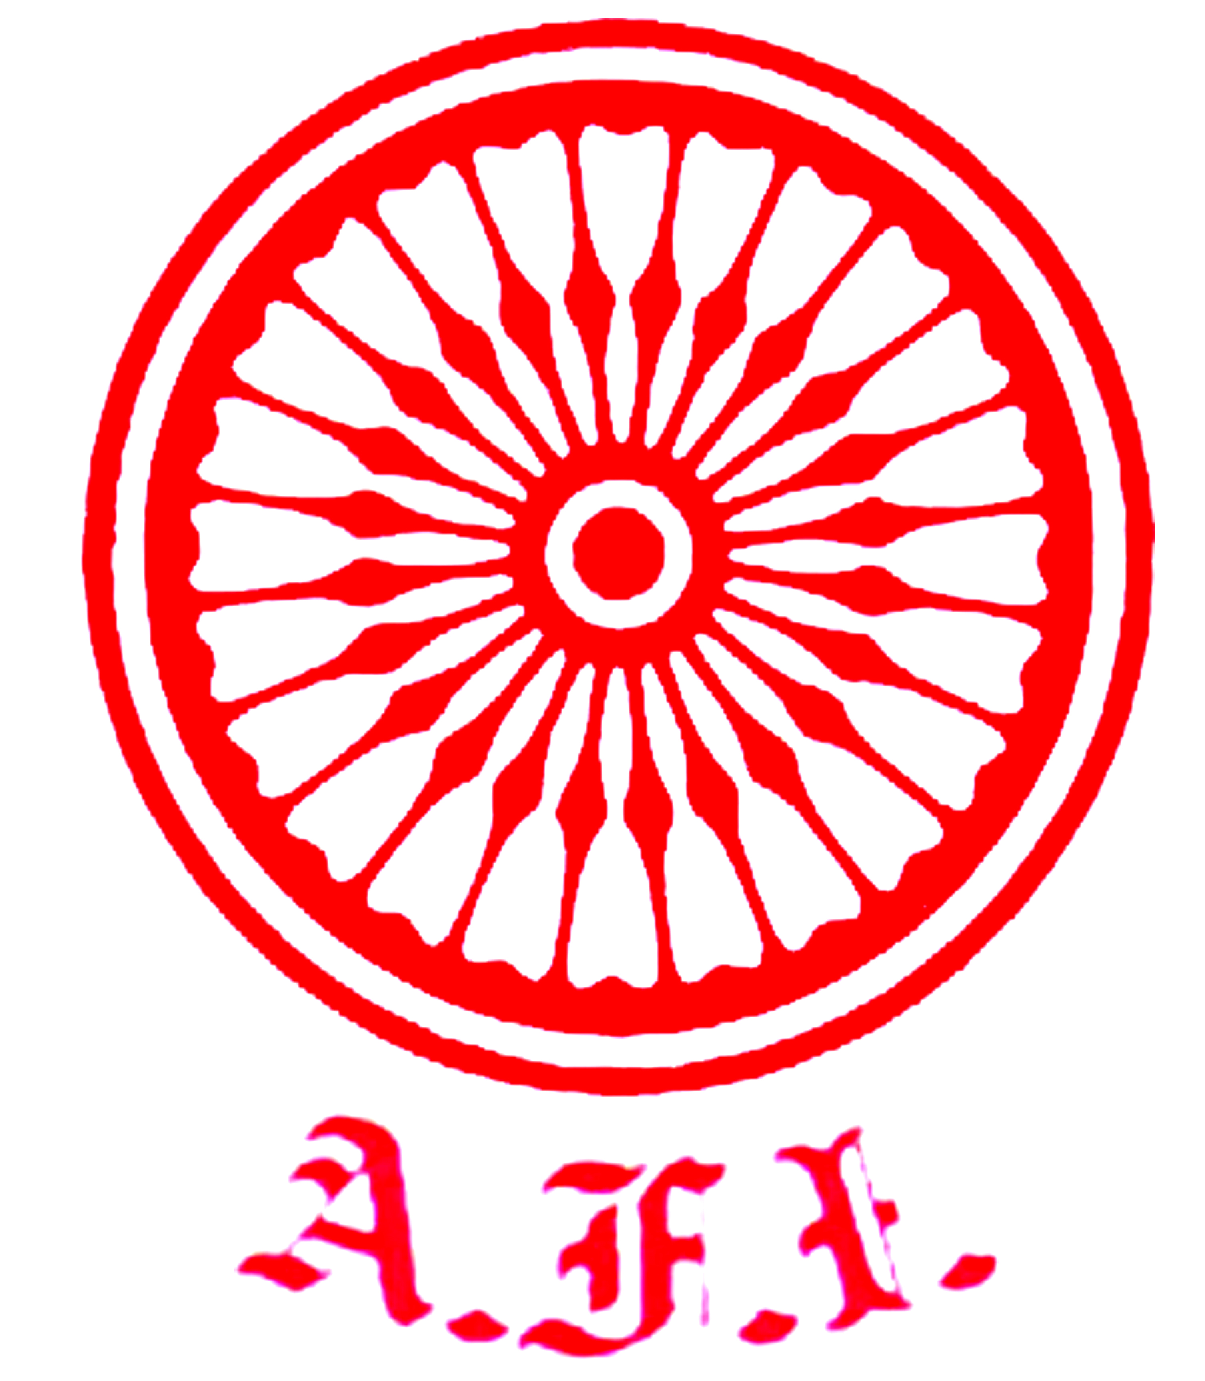
U. P. Athletics Association

Initiative of ATHLETICS UTTAR PRADESH

“दिशा”
Educational Deliberations for the Coaching Fraternity of Uttar Pradesh
Athletics Coaches, Physical education Teachers, members of Athletics fraternity
*~*~*~*~*~*
Topics

Nutrition.
Pylometrics.
Kids Athletics.
Fundamentals of Jump.
Fundamental of Throw.
Fundamentals of Running.
Skill Teaching & Coaching Skills.
Planning & Periodisation of a Season.
Doping in Athletics / Food Supplements.
Methods of Coaching – An athlete’s expectation.
Youth Development (Long Term Athlete development Plan).
*~*~*~*
~: Eminent faculty :~

Mr. P. Radhakrishnan Nair (Dy. Chief Coach AFI) Mrs. Aradhana Sharma (Nutritionist, Pune)
Mr. Volker Herrmann (High Performance Diretcor AFI) Mrs. Anjani Dubey (Ex-International Athlete, IIT Kanpur)
Mr. Rohit Tambe (Athletics Maharashtra - Mumbai) Mr. Parth Goswami (Legal Adsvisor, AFI)
Mr. Siddhartha Krishna (Athletics Uttar Pradesh- Saifai) Ms. Ishita Das (Athletics NS NIS Patiala)
Mr. G. Rajaraman (Senior Journalist) Mrs. Kamlesh Tiwana (SAI Lucknow)
Mr. Kamal Ali (Chief Coach – Juniors, AFI) Ms. Manisha Gawande (Athletics Maharashtra, Mumbai)
Dr. M. Booker (NS NIS Patiala) Mr. Sandeep Sarkaria (Elite International Athlete)
*~*~*~*
7th to 10th June 2020 * Sunday to Wednesday * 11.00 am

The Registration for participation in the Seminar may be made through following link.
https://forms.gle/34NqvdoAbXhpCpPh7
~: COORDINATORS :~

Sri Dinesh Kumar Jaiswal Chairman Coaching Committee  Mobile – 9415372693 *  Email - dineshsandhya1958@gmail.com | Sri Siddhartha Krishna - Executive Committee member  Mobile – 7376922226 *  Email – siddhuwalk46@gmail.com

Mr. Anil Kumar Sagar, IAS Dr. Devesh Dubey Ashutosh Bhalla
Sr. Vice President Treasurer Chairman
Chairman Planning Committee HOST Inspirer

