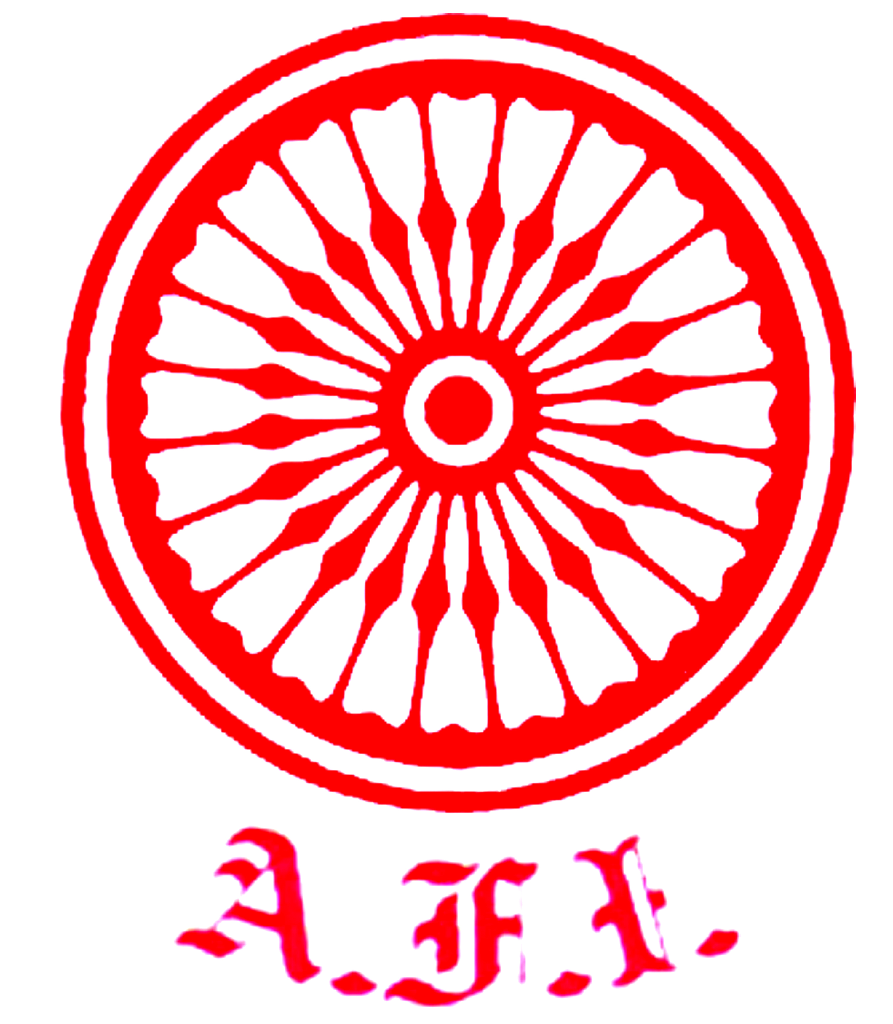
U. P. Athletics Association

Initiative of ATHLETICS UTTAR PRADESH
Under the auspices of Athletics Federation of India
“दिशा”
7th to 10th June 2020 * Sunday to Wednesday * 11.00 am
Educational Deliberations for the Coaching Fraternity of Uttar Pradesh

Inauguration Ceremony

7th June 2020 * Sunday * Day “1”

10.45 – 10.55 hrs. Assembly of Participants from all over Uttar Pradesh.

10.55 hrs. Arrival of Hony President U.P.Athletics Association.

11.00 hrs. Arrival of Chief Guest & Dignitaries.
Welcome Address by Sri Ashutosh Bhalla Ji - Chairman UPAA.
Presidential Remarks by Sri Kunwar Fateh Bahadur Ji - Sr. Vice President AFI.
Speech by Chief Guest – Sri Jayant Singh Chaudhary.
11.15 hrs. Speech by Chairman of the Session - Sri Sanjay Saraswat - Regional Director SAI. 11.17 hrs. Vote of Thanks Address by Dr. Devesh Dubey - Treasurer UPAA
11.20 hrs. Doping & Food Supplements by Sri P. Radhakrishnan Nair

- Dy. Chief National Coach – Indian Athletics - AFI.
- Coaching Development Director – AFI.
- World Athletics Coaches Education level ‘1’ & level ‘2’ Lecturer.
- World Athletics Level ‘5’ Coach.
- Graduated with Honour in International Coaches Enrichment Certificate Programme,
Delaware University, USA – under the sponsorship of IOC

12.00 hrs. Nutrition by Smt. Aradhana Sharma

- Senior Sports Science Consultant, Dept. of Sports and Youth Welfare, MP
- Adjt. Faculty, Department of Exercise and Sports Science, Manipal University.
- Senior Nutrition Consultant, Naval Tata Hockey Academy, Odisha.
- Expert Trainer, OGQ Coaches Excellence Programme

12.45 hrs. Doping – AFI No Needle Policy by Sri Parth Goswami

- Advocate
- Vice President - Delhi Athletics Association.
- Anti-Doping Law Expert.
13.15 hrs. Vote of Thanks Address by Dr. Devesh Dubey - Treasurer UPAA

*~*~*~*
Mr. Anil Kumar Sagar, IAS Dr. Devesh Dubey P. K. Srivastava
Sr. Vice President Treasurer Hony Secretary
Chairman Planning Committee HOST Organiser

